**Military Institute of Science and Technology**

**Department of CSE**

**CSE-310 (Networking Sessional)**

**VLSM (Variable-Length Subnet Mask)**

Design the following network in Packet Tracer using an IP address 192.168.10.0. Ensure that each PC can communicate with each other (use static routing).

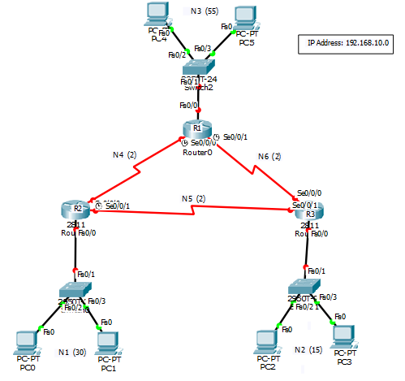

**Network Table:**

|  |  |  |  |  |  |  |
| --- | --- | --- | --- | --- | --- | --- |
| **Network** | **# of Host** | **Block Size** | **Prefix** | **Network Address &**  **Broadcast Address** | **Available Host IPs** | **Subnet Mask** |
| 3 | 55 | 26 = 64 | /26 | 192.168.10.0  &  192.168.10.63 | 192.168.10.1  to  192.168.10.62 | 255.255.255.192 |
| 1 | 30 | 25 = 32 | /27 | 192.168.10.64  &  192.168.10.95 | 192.168.10.65  to  192.168.10.94 | 255.255.255.224 |
| 2 | 15 | 25 = 32 | /27 | 192.168.10.96  &  192.168.10.127 | 192.168.10.97 to  192.168.10.126 | 255.255.255.224 |
| 4 | 2 | 22 = 4 | /30 | 192.168.10.128  &  192.168.10.131 | 192.168.10.129 to  192.168.10.130 | 255.255.255.252 |
| 5 | 2 | 22 = 4 | /30 | 192.168.10.132  &  192.168.10.135 | 192.168.10.133 to  192.168.10.134 | 255.255.255.252 |
| 6 | 2 | 22 = 4 | /30 | 192.168.10.136  &  192.168.10.139 | 192.168.10.137 to  192.168.10.138 | 255.255.255.252 |

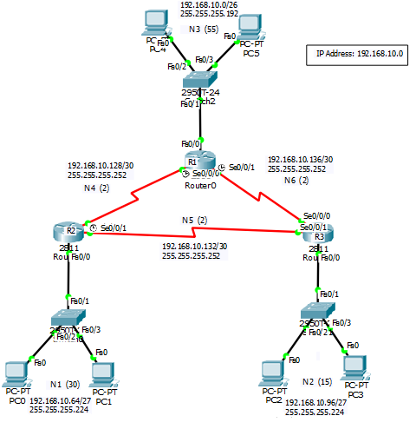

**Configure Router R1**

Router>enable

Router#configure terminal

Router(config)#hostname R1

R1(config)#interface FastEthernet0/0

R1(config-if)#ip address 192.168.10.1 255.255.255.192

R1(config-if)#no shutdown

R1(config-if)#exit

R1(config)#interface Serial0/0/0

R1(config-if)#ip address 192.168.10.129 255.255.255.252

R1(config-if)#no shutdown

R1(config-if)#clock rate 64000

R1(config-if)#k

R1(config)#interface Serial0/0/1

R1(config-if)#ip address 192.168.10.137 255.255.255.252

R1(config-if)#no shutdown

R1(config-if)#clock rate 64000

R1(config-if)#exit

R1(config)#ip route 192.168.10.64 255.255.255.224 192.168.10.130

R1(config)#ip route 192.168.10.96 255.255.255.224 192.168.10.138

R1(config)#ip route 192.168.10.132 255.255.255.252 192.168.10.130

R1(config)#do copy running-config startup-config

**Configure Router R2:**

Router>enable

Router#configure terminal

Router(config)#hostname R2

R2(config)#interface FastEthernet0/0

R2(config-if)#ip address 192.168.10.65 255.255.255.224

R2(config-if)#no shutdown

R2(config-if)#exit

R2(config)#interface Serial0/0/0

R2(config-if)#ip address 192.168.10.130 255.255.255.252

R2(config-if)#no shutdown

R2(config-if)#exit

R2(config)#interface Serial0/0/1

R2(config-if)#ip address 192.168.10.133 255.255.255.252

R2(config-if)#no shutdown

R2(config-if)#clock rate 64000

R2(config-if)#exit

R2(config)#ip route 192.168.10.0 255.255.255.192 192.168.10.129

R2(config)#ip route 192.168.10.96 255.255.255.224 192.168.10.138

R2(config)#ip route 192.168.10.136 255.255.255.252 192.168.10.129

R2(config)#do copy running-config startup-config

**Configure Router R3:**

Router>enable

Router#configure terminal

Router(config)#hostname R3

R3(config)#interface FastEthernet0/0

R3(config-if)#ip address 192.168.10.97 255.255.255.224

R3(config-if)#no shutdown

R3(config-if)#exit

R3(config)#interface Serial0/0/0

R3(config-if)#ip address 192.168.10.138 255.255.255.252

R3(config-if)#no shutdown

R3(config-if)#exit

R3(config)#interface Serial0/0/1

R3(config-if)#ip address 192.168.10.134 255.255.255.252

R3(config-if)#no shutdown

R3(config-if)#exit

R3(config)#ip route 192.168.10.0 255.255.255.192 192.168.10.137

R3(config)#ip route 192.168.10.64 255.255.255.224 192.168.10.133

R3(config)#ip route 192.168.10.128 255.255.255.252 192.168.10.133

R3(config)#do copy running-config startup-config

* Configurations of three routers are finished.
* Set the IP addresses in the six (6) PCs.
* Finally test ICMP packets transfer successfully.

**Practice:**

Design the following network in Packet Tracer using an IP address 192.168.0.0. Ensure that each PC can communicate with each other (use static routing).

